11.88: a) 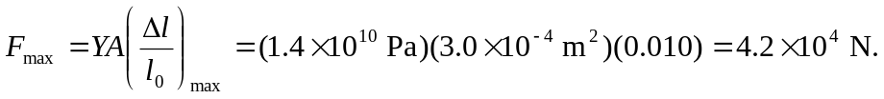

b) Neglect the mass of the shins (actually the lower legs and feet) compared to the rest of the body. This allows the approximation that the compressive stress in the shin bones is uniform. The maximum height will be that for which the force exerted on each lower leg by the ground is 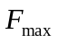found in part (a), minus the person’s weight. The impulse that the ground exerts is The speed at the ground is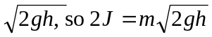 and solving for h,

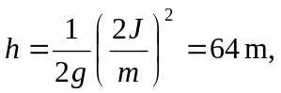
but this is not recommended.

